ANALISIS DESAIN DAN SISTEM

Muhammad Ilman Assiediqie (12030123140343)

Muhammad Biandra Wildan Aldityasmoro (12030123140231)

**Chapter 5 Summary: Data and Process Modeling**

**5.1 Introduction**

This section introduces the importance of data and process modeling in system analysis and design. It sets the foundation for understanding how these models help visualize and improve system processes.

**5.2 Overview of Data and Process Modeling Tools**

An overview of various tools used for data and process modeling, including their purposes and applications in system analysis.

**5.3 Data Flow Diagrams (DFDs)**

Explains what DFDs are and how they represent the flow of data within a system. It covers the basic symbols and conventions used in DFDs.

**5.4 Creating a Set of DFDs**

Guidelines and steps for creating a comprehensive set of DFDs, from context diagrams to detailed level diagrams.

**5.5 Guidelines for Drawing DFDs**

Provides best practices and rules for drawing clear and accurate DFDs, including tips on leveling and balancing DFDs to ensure consistency.

**Case in Point 5.1: Big Ten University**

A practical example illustrating the application of DFDs in a real-world scenario at Big Ten University.

**5.6 Data Dictionary**

Describes the purpose and structure of a data dictionary, which documents data elements and their attributes used in the system.

**5.7 Process Description Tools**

Covers various tools for describing processes, such as structured English, decision tables, and decision trees.

**Case in Point 5.2: Rock Solid Outfitters (Part 1)**

**Case in Point 5.3: Rock Solid Outfitters (Part 2)**

Examples showing the use of process description tools in the context of Rock Solid Outfitters.

**5.8 Logical versus Physical Models**

Explains the difference between logical models, which focus on system requirements and functionality, and physical models, which detail the system’s implementation.

**Case in Point 5.4: Tip Top Staffing**

A case study demonstrating the transition from logical to physical models in a staffing company.

**A Question of Ethics**

Discusses ethical considerations in data and process modeling.

**5.9 Chapter Summary**

Summarizes the key points covered in the chapter, reinforcing the importance of data and process modeling in system analysis and design.

**Data Flow Diagram (DFD) for a Clothes Ordering System**

**1. Context Diagram (Level 0 DFD)**

* **External Entities**:
  + **Customer**: Places orders and makes payments.
  + **Clothes Supplier**: Provides inventory.
  + **Sales Manager**: Oversees sales operations.
  + **Clothes Store**: Manages inventory and fulfills orders.
* **Processes**:
  + **Order Processing**: Handles customer orders.
  + **Inventory Management**: Manages stock levels.
  + **Payment Processing**: Manages payment transactions.
  + **Sales Management**: Oversees sales and customer interactions.
* **Data Stores**:
  + **Order Database**: Stores order details.
  + **Inventory Database**: Stores inventory levels.
  + **Customer Database**: Stores customer information.
  + **Sales Records**: Stores sales data.

**2. Detailed Diagram (Level 1 DFD)**

* **Processes**:
  + **1.0 Customer Order Entry**:
    - **Input**: Customer order details.
    - **Output**: Order confirmation.
    - **Data Store**: Order Database.
  + **2.0 Payment Processing**:
    - **Input**: Payment details.
    - **Output**: Payment confirmation.
    - **Data Store**: Payment records.
  + **3.0 Inventory Management**:
    - **Input**: Order details from Order Database.
    - **Output**: Updated inventory levels.
    - **Data Store**: Inventory Database.
  + **4.0 Sales Management**:
    - **Input**: Sales data.
    - **Output**: Sales reports.
    - **Data Store**: Sales Records.
  + **5.0 Supplier Management**:
    - **Input**: Inventory requests.
    - **Output**: Inventory updates.
    - **Data Store**: Inventory Database.

**3. Data Flow**

* **Customer** → **Order Processing**: Sends order details.
* **Order Processing** → **Order Database**: Stores order details.
* **Order Processing** → **Payment Processing**: Sends payment details.
* **Payment Processing** → **Payment Gateway**: Processes payment.
* **Payment Gateway** → **Payment Processing**: Sends payment confirmation.
* **Order Processing** → **Inventory Management**: Sends order details.
* **Inventory Management** → **Inventory Database**: Updates inventory levels.
* **Inventory Management** → **Supplier Management**: Sends inventory requests.
* **Supplier Management** → **Inventory Database**: Updates inventory levels.
* **Sales Management** → **Sales Records**: Stores sales data.
* **Sales Management** → **Sales Manager**: Sends sales reports.
* 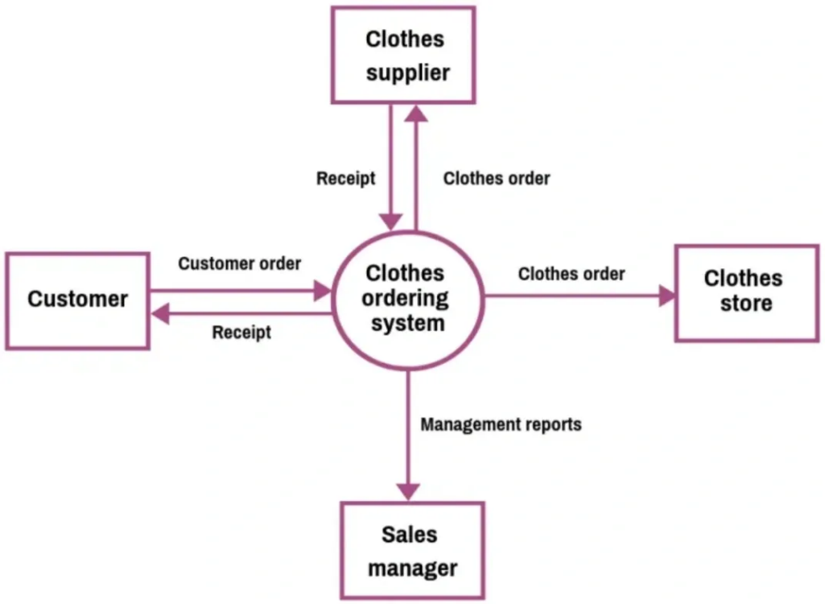**Clothes Store** → **Customer**: Fulfills orders.